Functional connectivity and microbial transmission pathways in Fennoscandian rodents

Aim
This project aims to develop a “Microbial Sensor” - a high-resolution biological tracer that uses gut microbiome similarity to map the infrastructure of social and environmental contact in wild host populations. By bridging field ecology with long-read sequencing and Bayesian modelling, this project seeks to define how functional connectivity (the actual networks of contact) governs biological flow across host populations. This approach addresses a fundamental challenge in disease ecology: understanding how pathogens persist in the landscape and how endemic ranges expand through host populations. We will apply a unified molecular-statistical pipeline across two complementary work packages:
- WP1: Comparative Model Development. Establish the microbial signal of connectivity by contrasting connected and unconnected host dyads using archived long-term rodent monitoring studies from Finland (Pallasjärvi) and Sweden (Grimsö).
- WP2: Longitudinal Validation. Validate the sensor’s temporal accuracy by ground-truthing microbial sharing against real-time interaction data using an intensive longitudinal grid at Grimsö.

Background
The Challenge: Quantifying the Infrastructure of Contact and Connectivity. Rodent contact networks emerge from social organisation and movement ecology rather than density alone¹. These networks define the functional connectivity through which biological material (i.e., pathogens) circulate within and between populations. However, most ecological models continue to approximate transmission potential using population density, implicitly assuming connectivity rather than measuring it². This is particularly pronounced in small-mammal systems, where direct physical interactions and indirect space-sharing are tightly coupled yet ecologically distinct processes.
This gap is critical for environmentally persistent agents such as Puumala orthohantavirus (PUUV), which remain infectious outside the host for 2–3 weeks at room temperature and up to 5 weeks under snow cover³. In such cases, unobserved environmental contact via shared infrastructure can drive outbreaks more effectively than direct physical encounters. By conceptualising rodent populations as metacommunities linked by these discrete interactions, this project seeks to identify the ecological rules governing how connectivity is maintained or disrupted, using rodent-borne zoonoses as a biologically well-characterised model system.

State-of-the-Art (SOA): The current SOA for sensing wildlife contact relies on logistically intensive technologies such as RFID-logging and Capture-Mark-Recapture (CMR)⁴. While providing high-resolution data, these approaches often reduce contact history to coarse binary representations of interaction that fail to capture the intensity and cumulative duration of exposure. As a result, key ecological properties of connectivity such as the repeated use of shared infrastructure or the temporal ordering of interactions, remain largely unobserved.
Recent advances in molecular ecology suggest that gut microbiota similarity can serve as a biological integrator of these past associations, often predicting social networks more accurately than simple spatial proximity⁵. However, these efforts have struggled to resolve a fundamental confounding factor: spatial-social coupling⁶. In many rodent populations, habitat structure, movement pathways, and social proximity are tightly intertwined, such that whole-community microbiota similarity is statistically non-identifiable with respect to direct physical interactions versus shared environmental exposure⁷.
This limitation is particularly pronounced in cyclic species such as the bank vole (Clethrionomys glareolus), the host of PUUV. Their movement ecology and social structure are fundamentally reshaped across multi-year density fluctuations, cycles that vary significantly in amplitude and periodicity across the Fennoscandian gradient (e.g., between the high-latitude systems of Northern Finland and the temperate forests of Grimsö, Sweden)⁸. To date, we lack a scalable indicator of functional connectivity that remains robust across these contrasting demographic and geographic contexts.

Beyond the SOA: This project moves beyond the SOA by adopting a trans-Fennoscandian comparative approach to develop a generalisable Microbial Sensor. The key innovation lies in moving from community-level correlation to process-partitioned, strain-level transmission tracking. By utilising high-resolution long-read sequencing, we can identify the specific, shared microbial taxa that signify recent host association. This allows us to move past binary interactions and resolve the intensity of interactions through two biologically grounded channels (Figure 1A and D). Importantly, we treat social contact as a nested, high-intensity subset of environmental connectivity, using the microbial sensor to decompose these overlapping signals:
- The Social Channel (direct contact): We focus on obligate anaerobic, non-spore forming taxa (e.g., Bacteroidales), which have limited capacity for environmental persistence and are common commensal microbes in the animal gut microbiota. This captures microbial signatures that reflect recent physical proximity and direct host–host interactions.
- The Environmental Channel (indirect contact): We focus on aerotolerant and/or environmentally resilient taxa, including spore-forming clades (e.g. subsets of the Lachnospiraceae). By comparing faecal profiles with paired environmental samples (soil and nest material), we can distinguish between transient environment noise and the specific host-associated taxa that persist in shared infrastructure to drive indirect connectivity⁵.
By integrating this microbial-statistical pipeline with established vole population grids in Finland and Grimsö, we will first define the "General Rule" of connectivity across host density cycles (WP1). We will then leverage intensive longitudinal tracking to provide the high-resolution validation required to weight these connectivity networks in real-time (WP2).

Project Plan
This project adopts an ecology-first framework, prioritising the collection and integration of empirical field data to infer functional connectivity in wild rodent populations. We apply a unified PacBio-Bayesian pipeline across both work packages, moving from establishing large-scale patterns (WP1) to mechanistic validation (WP2) (Figure 1B).

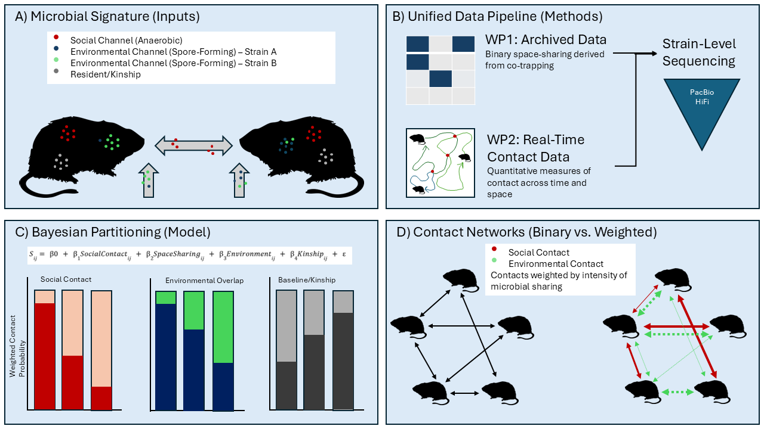
Figure 1: The Microbial Sensor Pipeline. A) Individual host profiles are partitioned into distinct channels: the social channel (red), strain-specific environmental channels (blue/green) reflecting separate home-range communities, and shared resident/kinship markers (grey). B) Both cross-sectional archived data (WP1) and longitudinal real-time contact data (WP2) are processed through a single pipeline utilizing PacBio HiFi strain-level sequencing to resolve specific transmission events. C) Microbial similarity is decomposed into primary ecological drivers. Each bar represents a unique host dyad, illustrating the relative contribution of social contact, environmental overlap, and kinship/baseline similarity. D) A direct comparison between traditional binary networks (left), which assume all overlapping individuals are connected equally, and the weighted, channel-descriptive networks (right) enabled by the microbial sensor.

WP1: Comparative Model Development (Cross-sectional Benchmarking)
WP1 establishes the Microbial Sensor framework by quantifying how distinct modes of host contact are reflected in structured components of the gut microbiome. WP1 does not attempt to distinguish contact modes directly; instead, it identifies microbial similarity structures that cannot be reproduced under null models parameterised by host density, spatial overlap, and trapping co-occurrence, thereby falsifying density-only transmission assumptions and defining the constrained parameter space within which mechanistic transmission processes must operate.
Data sources: In collaboration with Prof. Henttonen, we obtain rodent samples from long-term grids established in Pallasjärvi (Finnish Lapland). In collaboration with the national small rodent monitoring programme we will also obtain rodent samples from Grimsö (Sweden). These two datasets represent repeated cross-sectional sampling with each sample representing a snapshot of an individual's microbial and social history.
Sample size: By reconstructing the gradient of host association, ranging from co-trapping within the same quadrat to captures on distant grids, we will identify high-information dyads. We will select 50 connected and 50 unconnected dyads from each site (200 total samples), providing a statistically powerful contrast between individuals with high vs. zero probability of direct interaction.
Environmental context: We will sequence paired environmental samples from the trapping locations. While the temporal resolution of soil samples may differ from the host's immediate gut composition, these provide the necessary baseline to differentiate between background environmental noise and the host-associated taxa that persist in the landscape.
Molecular pipeline: Total DNA will be extracted from each sample to support our unified pipeline. PacBio HiFi 16S sequencing for the microbiome and host genomics to incorporate kinship as a factor in our models will be used⁹. This ensures that observed microbial similarity is a result of shared contact, controlling for genetic relatedness.
Comparative and modelling framework: We will quantify how microbial similarity integrates home-range overlap and co-trapping history under contrasting demographic regimes (population peaks vs. crashes). We use Pattern-Oriented Modelling to assess which large-scale microbial assembly patterns cannot be reproduced by host density and spatial overlap alone, thereby defining the foundational parameter space for the Microbial Sensor¹⁰. We will separate networks by functional group (age, sex, and maturity status) to avoid the biases inherent in pooling demographically distinct sub-populations.
WP2: High-Resolution Triangulation and Validation (Grimsö, Sweden).
WP2 provides mechanistic validation by directly resolving transmission pathways that are structurally non-identifiable in cross-sectional data.
Field methodology: I will implement an intensive longitudinal live-trapping grid (3ha) at Grimsö. To capture high-resolution temporal data, we will conduct trapping campaigns every three weeks over a 3-month period (3–4 trap nights per session). This design allows for the repeated sampling of individuals across their demographic and reproductive shifts. The implementation of this high-intensity design is supported by my prior experience in managing complex rodent-trapping logistics in high-risk field environments. Individuals are monitored via: 1) RFID-logging for temporally ordered host–host interactions; 2) CMR, providing lower-resolution but spatially extensive contact proxies; and 3) Microbial sampling, (faecal swabs, paired soil/nest material) to capture host-associated and environmental exposure.
Sampling and molecular pipeline: We will aim to track 20-40 individuals over the trapping period, collecting 100 longitudinal faecal samples alongside paired environmental swabs. The molecular pipeline remains identical to WP1, ensuring data comparability across the project.
Bayesian modelling: We will apply a unified Bayesian hierarchical model to both WPs. In WP2 however, we will use the temporally ordered monitoring data to ground truth the model decomposing contact related coefficients into social contact and space sharing. By partitioning the microbial similarity ($S_{ij}$) into contributions from distinct ecological processes (shared space vs. direct interaction) and kinship, we will quantify the Microbial Sensors accuracy in detecting the cumulative contact history that traditional trapping snapshots miss (Figure 1C):
$$S_{ij}= β0 + β_{1}SocialContact_{ij} + β_{2}SpaceSharing_{ij} + β_{3}Environment_{ij} + β_{4}Kinship_{ij} + ε$$
The term ε represents the residual error, capturing individual-level stochasticity and unobserved environmental variation not accounted for by the primary predictors.

Anticipated Results & Applicant Suitability
This project delivers a mechanistic framework for quantifying functional connectivity. The primary outcome is a pathogen-agnostic Microbial Sensor that integrates host-associated microbial data with ecological context to infer weighted connectivity networks. This fellowship facilitates a critical skill-exchange for my continuing professional development bridging my expertise in high-intensity field epidemiology and quantitative disease ecology with the world-class molecular microbial training provided by the Videvall lab at the Department of Ecology and Genetics (IEG). By integrating these fields, the project will:
- Identify which components of host-associated microbial structure are explainable by demography and space alone, and which signify explicit transmission events.
- Produce weighted contact matrices that explicitly separate direct social interactions (Social Channel) from indirect environmental space-sharing (Environmental Channel).
- Establish the ecological rules by which functional connectivity is restructured across multi-year host density cycles using Fennoscandian vole systems as a global model.
- Deliver reproducible analytical workflows, including Bayesian hierarchical models and DADA2-based bioinformatics pipelines, as documented R scripts to support transparency and reuse within the ecological and evolutionary research community.
Risk Mitigation: Logistical risks are mitigated by the established research infrastructure at Grimsö Wildlife Research Station and my extensive prior experience managing complex rodent-trapping logistics. Analytical uncertainty is addressed through a sequential design: WP1 defines the limits of microbial identifiability using broad cross-sectional data, while WP2 provides the ground-truth through longitudinal tracking and triangulation of contact. Bayesian hierarchical models will be used to explicitly manage measurement error and spatial dependence.
Project Timeline:
Activity | M1–6 | M7–12 | M13–18 | M19–24
WP1: Sample retrieval & targeted dyadic selection (Finland/Grimsö) | X | X
WP2: Grimsö 3ha grid setup & 3-month intensive trapping campaign |  | X | X
Lab: DNA extractions (IEG) & PacBio HiFi sequencing (NGI Stockholm) |  | X | X
Analysis: Bayesian modelling, R-pipeline documentation, & synthesis |  | X | X | X

Budget Motivation
The proposed budget is structured to leverage existing research infrastructure at the Department of Ecology and Genetics (IEG) and NGI Stockholm/ScilifeLab. The primary allocation supports my role leading the project. By prioritising high-resolution PacBio HiFi sequencing via NGI Stockholm, the project ensures the most efficient use of foundation funds. IEG bench fees support DNA extraction and library preparation, while the UPPMAX cluster provides the high-performance computing required for microbial and host-genomic data processing. Allocation is included for intensive fieldwork at Grimsö and a focussed scientific exchange with Prof. Henttonen, ensuring a two-way transfer of methodological expertise between the Finnish and Swedish research environments.

References

1. Borremans, B. et al. Oikos 126, 792–800 (2017).
2. Suzán, G. et al. Ecol. Evol. 5, 865–873 (2015).
3. Kallio, E. R. et al. J. Gen. Virol. 87, 2127–2134 (2006).
4. Gilbertson, M. L. J., White, L. A. & Craft, M. E. Methods Ecol. Evol. 12, 76–87 (2021).
5. Raulo, A. et al. Nat. Ecol. Evol. 8, 972–985 (2024).
6. Wanelik, K. M. et al. Anim. Microbiome 7, 42 (2025).
7. Schmid, D. W. & Risely, A. J. Anim. Ecol. 92, 790–793 (2023).
8. Henttonen, H. Therya 13, 33–38 (2022).
9. Andrews, K. R., Good, J. M., Miller, M. R., Luikart, G. & Hohenlohe, P. A. Nat. Rev. Genet. 17, 81–92 (2016).
10. Grimm, V. et al. Science 310, 987–991 (2005).

